**Homework 3 Solution**

1. Thinking like an instructor: Make up a solvable Diophantine equation. Explain what process you used and which results you relied on during the process.

3x + 369633636969691y = 400 and 5x + 1432175741y = 36

Basically I chose my coefficients to have a GCD of 1 and set it equal to literally any random number I wanted and it's possible.

I created two numbers with a common, slightly large gcd by using the prime numbers less than 100 list. I chose *p*=89, and let $a=89⋅43, b=89⋅97.$ I also chose one of the multipliers to be a bit more than twice the other multiplier so that in the Euclidean algorithm, the remainder will be small. If I chose 83 instead of 97, the remainder will not be much smaller than *a* in the first step, which helps keep the number of steps low.Then if I choose the right hand side a multiple of the gcd, I know there’s a solution, so say $89⋅3=267.$

$3827x+8633y=267.$

1. Use Euclidean algorithm to find the gcd of the following pairs:   
   a.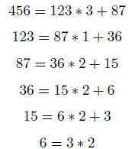



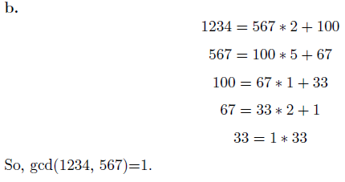

1. What are the possible values of $gcd(8n^{2}+14n+6, 2n+3)=1$? If you guess a possible value, make sure that it occurs.

For any *n, $8n^{2}+14n+6=(2n+3)(4n+1)+3$* , so anything which divides both numbers divides 3. This means gcd can be 1 or 3. For *n*=1, gcd(28,5)=1, and for *n*=3, gcd(120,9)=3. So both values occur.

* $8n^{2}+14n+6=(4n+1)(2n+3)+3$ so, by calculating remainders,
* $gcd(8n^{2}+14n+6, 2n+3)=gcd(3, 2n+3)=gcd(3,2n)$.
* $gcd(3, 2n)=1$ if and only if $n$ is not a multiple of 3.
  + This is because if $n$ is not a multiple of 3 then there exists $x,y$ such that $3x+2ny=1$ which using the $gcd$ as a linear combination means that $gcd(3, 2n)=1$.
  + Conversely, if $n$ is a multiple of 3 then $3$ and $2n$ will share a factor of at least 3 and their $gcd$ will be at least 3, and thus not 1.

1. a. Find an integer solution to the equation $561x+379y=1$.

Through the Division/Euclidean Algorithm, we can get

561 ( -177 ) + 379 ( 262 ) = 1

b. Find a second solution with *x>*0.

To do this we will multiply our whole last equation by -378. This will give us

561 * (66906) + 379 (-99036) = -378

Next we add 379 to both sides to get

561 * (66906) + 379 (-99036+1) = -378 +379

So

561 * (66906) + 379 (-99035) = 1

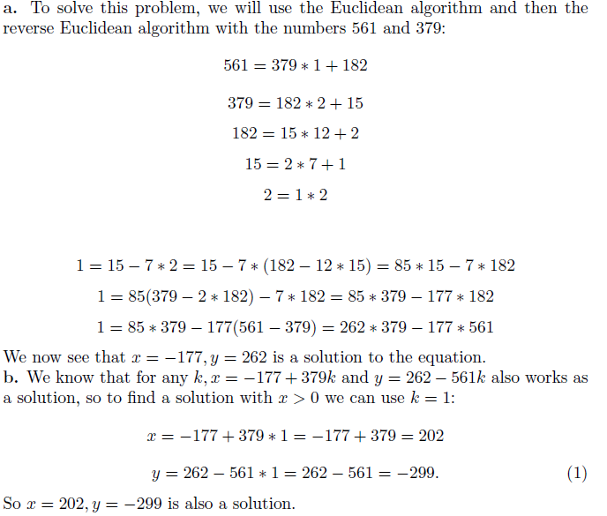

1. Show that [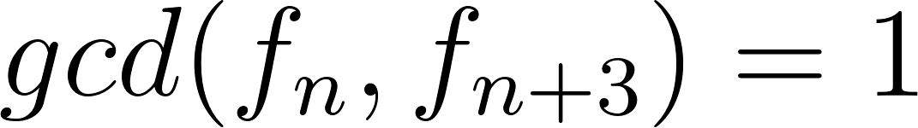](https://www.codecogs.com/eqnedit.php?latex=gcd(f_n%2C%20f_%7Bn%2B3%7D)%3D1#0) or 2.

Since f_n+3 = 4 f_n + f_n-3 for n>6 Notice this is essentially the Euclidean algorithm. This means that GCD ( f_n+3 , f_n ) = GCD ( f_n , f_n-3 ). Therefore, continuing in this way, we can reduce each GCD ( f_n+3 , f_n ) to one of the base cases of GCD (f_3, f_0), GCD (f_4, f_1) or GCD (f_5, f_2). Note that

GCD (f_3, f_0) = GCD (2, 0) = 2

GCD (f_4, f_1) = GCD (3, 1) = 1

GCD (f_5, f_2) = GCD (5, 1) = 1

So GCD ( f_n+3 , f_n ) is 1 or 2 depending on if n is divisible by 3.

Suppose $d |{ f}_{n}$ and $d |{ f}_{n+3}.$ Then $d | f_{n+3}-f_{n}= 2f_{n+1}.$ So $d | f_{n }$ and $d | {2f}_{n+1}.$ If $d$ is even, consider $g=d/2.$ Then $g | f_{n+1}$ and $g | f_{n}.$ If $d$ is not even, then $d | f_{n+1}.$ In either case, we have a factor that divides both $f_{n}$ and $f_{n+1}.$ This means that this factor also divides $f_{n+1}-f_{n}=f_{n-1}.$ Continuing in this way, we see that this factor divides $f_{3}-f_{2}=3-2.$ So either $d/2=1$ or $d=1.$ Note also that $gcd(f_{1}, f_{4})=gcd(1,5)=1$ and $gcd(f_{2}, f_{5})=gcd(2,8)=2.$ So both values occur.

1. Prove that if *c>*0, then [](https://www.codecogs.com/eqnedit.php?latex=lcm(ac%2Cbc)%3Dc%5Ccdot%20lcm(a%2Cb)#0).

By definition of lcm, $a | lcm(a,b)$ and $b | lcm(a,b),$ so both $ac$ and $bc$ divide $c⋅lcm(a,b),$ and hence $c⋅lcm(a,b)$ is a common multiple of $ac$ and $bc$. Therefore $lcm(ac, bc)≤c⋅lcm(a,b).$ (1)

By definition of lcm, $ac | lcm(ac, bc)$ and $bc | lcm(ac, bc).$ So $a | lcm(a, b)/c$ and $b | lcm(a, b)/c.$ This means that $lcm(a, b)/c$ is a common multiple of $a$ and $b$. Therefore $lcm(ac, bc)/c≥lcm(a, b)$. (2)

Combining (1) and (2) gives us that $lcm(ac, bc)=c⋅lcm(a, b)$.

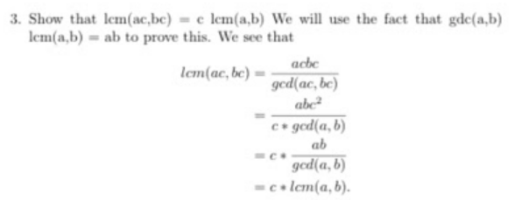

Note: For this method, we also have to separate the case for when *a* or *b*=0 and also “without loss of generality” assume a, b>0 because lcm(a,b)=lcm(|a|, |b|), but these are pretty straightforward and I don’t have the source for this solution :)

1. Show that if [](https://www.codecogs.com/eqnedit.php?latex=gcd(a%2Cb)%3Dr%20%2C%20gcd(a%2Cc)%3Ds#0) and [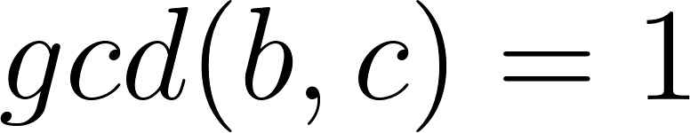](https://www.codecogs.com/eqnedit.php?latex=gcd(b%2Cc)%3D1#0), then [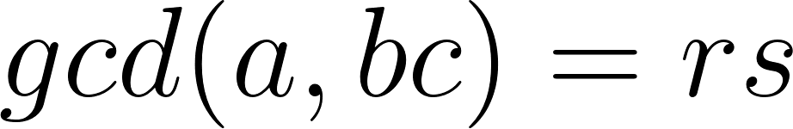](https://www.codecogs.com/eqnedit.php?latex=gcd(a%2Cbc)%3Drs#0). Give an example to show that this need not be true if [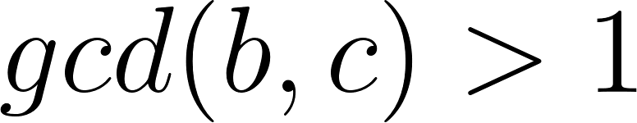](https://www.codecogs.com/eqnedit.php?latex=gcd(b%2Cc)%3E1#0).

We will use Theorem 4 (from Week 2 activity) characterization of the gcd to prove $gcd(a,bc)=gcd(a,b)⋅gcd(a,c).$ So we need to show: $1) gcd(a,b)⋅gcd(a,c)>0$  
 (which is obvious)

$2) gcd(a,b)⋅gcd(a,c) | a$ and $gcd(a,b)⋅gcd(a,c) | bc$:

The latter is obvious, and the first follows from Theorem 5 of Week 2 activity. What we want to show is equivalent to $gcd(a,c) | \frac{a}{gcd(a,b)}$ because we can multiply both sides by $gcd(a,b).$ To show $gcd(a,c) | \frac{a}{gcd(a,b)}$, note that $gcd(a,c) | gcd(a,b)⋅\frac{a}{gcd(a,b)}$ and $gcd(gcd(a,c), gcd(a,b))=1$ because $gcd(a,b)=1.$ Therefore, by Theorem 5, .

3) For every common divisor *d* of *a* and *bc, $d | gcd(a,b)⋅gcd(a,c)$* :

Suppose $d | a$ and $d | bc.$ Let $g=gcd(d,b).$ Then $g | a$ and $g | b,$ so $g | gcd(a,b).$ Now consider $d/g.$ If we can show $d/g | gcd(a,c)$, we are done. Note that $g⋅d/g | a,$ so $d/g | a.$ Also, $d/g | bc/g$ and $gcd(d/g, b/g)=1,$ so $d/g | c$ by Theorem 5. This means $d/g | gcd(a,c).$ Hence, $d=g⋅d/g$ divides $gcd(a,b)⋅gcd(a,c).$

Therefore, $gcd(a,b)⋅gcd(a,c)$ is equal to the gcd of *a* and *bc.*

The gcd equality is not true if we consider the following example: $gcd(6, 8)=2=r,$ $gcd(6, 10)=2=s$ 
, $gcd(8, 10)=2≠1$ and $gcd(6, 80)=2≠rs.$

We will show that $gcd(a,bc)=gcd(a,b)⋅gcd(a,c)$ by showing $gcd(a,bc)≤gcd(a,b)⋅gcd(a,c)$ and $gcd(a,bc)≥gcd(a,b)⋅gcd(a,c).$ First note that $gcd(gcd(a,b),gcd(a,c))=1$ because $gcd(b,c)=1.$ So $gcd(a,b)⋅gcd(a,c) | a$ since each divides *a* and they are relatively prime (second corollary to Theorem 5 in Week 2 class activity). Also $gcd(a,b)⋅gcd(a,c) | b⋅c$ because each gcd divides *b* and *c,* respectively. So $gcd(a,b)⋅gcd(a,c)$ divides both *a* and *bc*, which means $gcd(a,bc)≥gcd(a,b)⋅gcd(a,c)$. To show the other inequality, consider $d=gcd(a,bc).$ Let $g=gcd(d,b).$ Then $g | gcd(a,b).$ Note that the remaining part of *d,* i.e. $d/g | a$ and $d/g | bc/g.$ But $gcd(d/g, b/g)=1,$ so by Theorem 5 (Ibid.) $d|g | c.$ Therefore, $d/g | gcd(a,c).$ Then $d=g⋅d/g | gcd(a,b)⋅gcd(a,c).$ This proves the other inequality, and finishes the proof.

Hmm.. why reinvent the wheel? I decided not to do a third solution and searched for it online instead. Here are two possible solutions (the first one uses half of my first solution above):  
<https://math.stackexchange.com/questions/536179/prove-that-if-gcda-b-1-then-gcdab-c-gcda-c-gcdb-c?rq=1>

<https://math.stackexchange.com/questions/1492022/does-gcda-bc-divides-gcda-b-gcda-c/1492083>

(The second answer in this second link is another solution, but it seems to have a few extra steps.)

1. Write a code to implement the Euclidean algorithm to find gcd.

